The result here is from running: (for the data 0 - 1000)

python evalFunctionAndAUC -f "../data/fuzzyScores_0-1000.txt" -m "../data/1000annotate.csv" -p 0.2 0.4 0.5 0.6 0.8 -save "temp"

The result is:

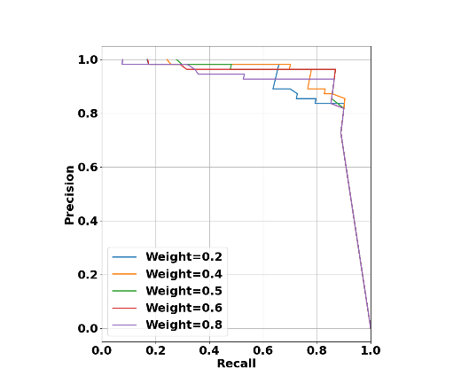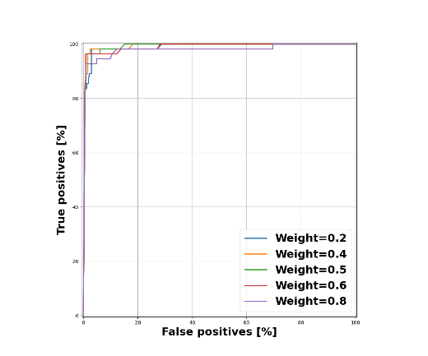

The console output is:  


--best weight percentage is 0.5.